Octagonal Prismoid

Definition
# Source: AI Source: Provided by: [Data Path: Persons Table -> ID Column: 1, Name_En Column: Motasem Essam] -> From: [ChatGPT] on [7/25/2026]
An Octagonal Prismoid is a polyhedron with two parallel octagonal bases, each having eight sides and eight vertices, connected by eight quadrilateral lateral faces.
The upper and lower octagonal bases may differ in size, shape, or orientation. The connecting edges must be arranged so that each lateral quadrilateral is planar.
An octagonal prismoid has 10 faces, 24 edges, and 16 vertices.

Geometric Structure
# Source: AI Source: Provided by: [Data Path: Persons Table -> ID Column: 1, Name_En Column: Motasem Essam] -> From: [ChatGPT] on [7/25/2026]
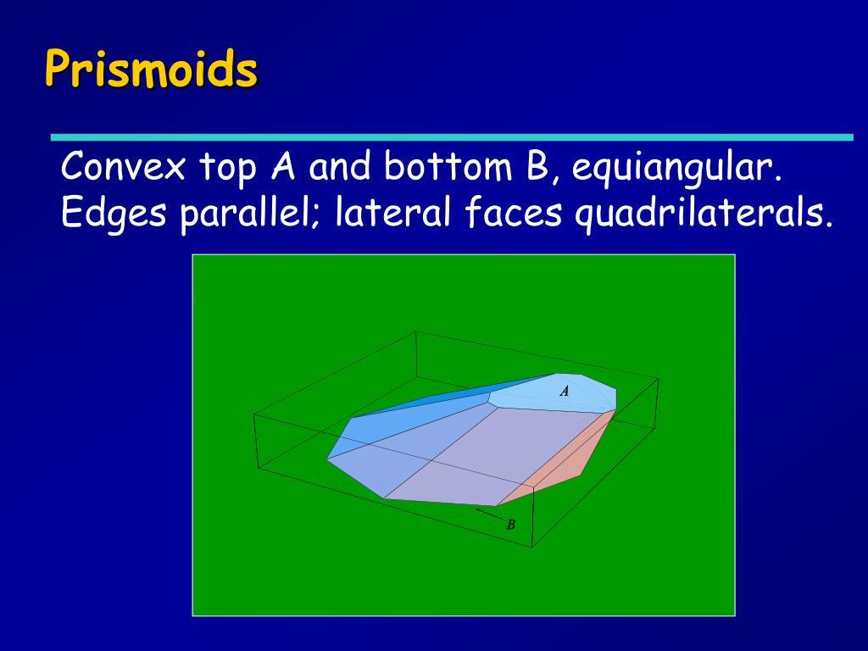
Its main elements are:
- Lower Octagonal Base: The bottom octagonal face.
- Upper Octagonal Base: The top octagonal face, parallel to the lower base.
- Lateral Faces: Eight quadrilateral faces connecting corresponding sides of the two bases.
- Lateral Edges: Eight edges connecting corresponding vertices of the bases.
- Vertices: Sixteen vertices in total.
- Altitude: The perpendicular distance between the two base planes.
- Midsection: A cross-section parallel to the bases, taken halfway between them.

Face Composition
# Source: AI Source: Provided by: [Data Path: Persons Table -> ID Column: 1, Name_En Column: Motasem Essam] -> From: [ChatGPT] on [7/25/2026]
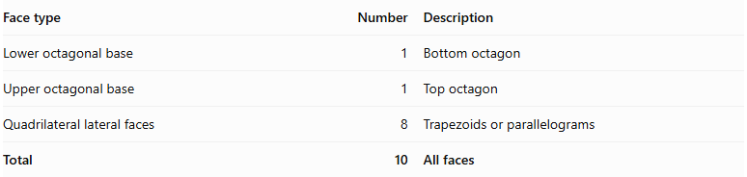
Face type | Number | Description
Lower octagonal base | 1 | Bottom octagon
Upper octagonal base | 1 | Top octagon
Quadrilateral lateral faces | 8 | Trapezoids or parallelograms
Total | 10 | All faces

Mathematical Properties
# Source: AI Source: Provided by: [Data Path: Persons Table -> ID Column: 1, Name_En Column: Motasem Essam] -> From: [ChatGPT] on [7/25/2026]
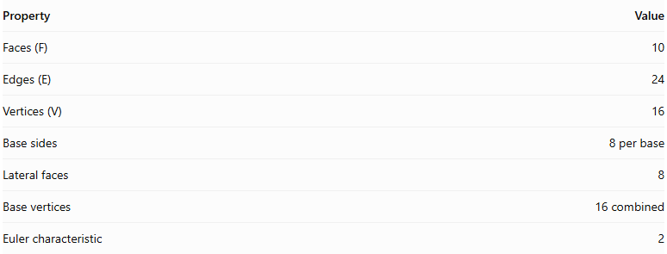
Property | Value
Faces (F) | 10
Edges (E) | 24
Vertices (V) | 16
Base sides | 8 per base
Lateral faces | 8
Base vertices | 16 combined
Euler characteristic | 2
Euler's Formula:
$$V-E+F=2$$
$$16-24+10=2$$
Volume — Prismoidal Formula:
$$V=\frac{h}{6}(A_{1}+4A_{m}+A_{2})$$
Where:
- $A_{1}$ = Area of the lower octagonal base.
- $A_{2}$ = Area of the upper octagonal base.
- $A_{m}$ = Area of the midsection parallel to the bases.
- $h$ = Perpendicular distance between the bases.
This formula applies to prismoids satisfying the required geometric conditions.
Area of a Regular Octagon:
$$A=2(1+\sqrt{2})s^{2}$$
Where $s$ is the side length of the regular octagon.

Geometric Characteristics
# Source: AI Source: Provided by: [Data Path: Persons Table -> ID Column: 1, Name_En Column: Motasem Essam] -> From: [ChatGPT] on [7/25/2026]
- It has two parallel octagonal bases.
- Both bases have eight sides and eight vertices.
- It has eight quadrilateral lateral faces.
- Its lateral faces may be trapezoids or parallelograms.
- The bases do not have to be congruent or similar.
- Its altitude is measured perpendicular to the base planes.
- Its midsection is parallel to both bases.
- It is a type of prismoid with the same number of vertices in both parallel bases.

Types of Octagonal Prismoids
# Source: AI Source: Provided by: [Data Path: Persons Table -> ID Column: 1, Name_En Column: Motasem Essam] -> From: [ChatGPT] on [7/25/2026]
- Regular Octagonal Prismoid: Both bases are regular octagons.
- Irregular Octagonal Prismoid: At least one base is an irregular octagon.
- Similar-Bases Octagonal Prismoid: The two octagonal bases are similar polygons.
- Non-Similar-Bases Octagonal Prismoid: The two octagonal bases are not similar polygons.
These are descriptive subdivisions for classification rather than universally standardized solid names.

Constructing a Octagonal Prismoid

Geometric Instruments
# Source: AI Source: Provided by: [Data Path: Persons Table -> ID Column: 1, Name_En Column: Motasem Essam] -> From: [ChatGPT] on [7/25/2026]
The following instruments can be used to construct an octagonal prismoid using traditional geometric drawing methods:
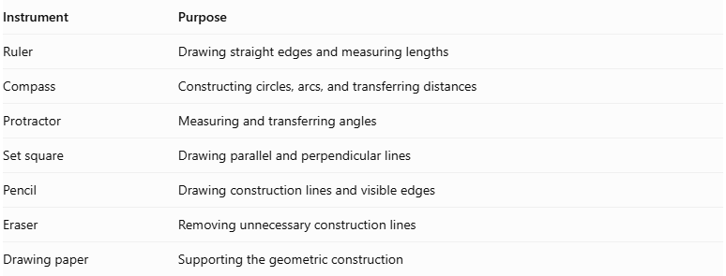
Instrument | Purpose
Ruler | Drawing straight edges and measuring lengths
Compass | Constructing circles, arcs, and transferring distances
Protractor | Measuring and transferring angles
Set square | Drawing parallel and perpendicular lines
Pencil | Drawing construction lines and visible edges
Eraser | Removing unnecessary construction lines
Drawing paper | Supporting the geometric construction
Important note about the regular octagon: A regular octagon can be constructed exactly using an unmarked straightedge and compass. Its central angle is ${45}^{°}$, and its interior angle is ${135}^{°}$.

Instrument-Based Construction Procedures

Method 1: Constructing from Two Parallel Octagonal Bases
# Source: AI Source: Provided by: [Data Path: Persons Table -> ID Column: 1, Name_En Column: Motasem Essam] -> From: [ChatGPT] on [7/25/2026]
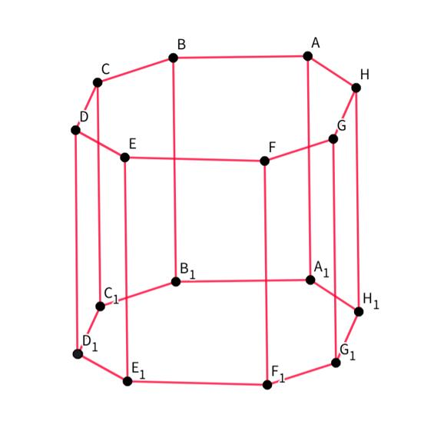
- Draw the lower octagonal base $ABCDEFGH$ using a ruler and compass.
- If constructing a regular octagon, divide a circle into eight equal central angles of ${45}^{°}$.
- Establish the required perpendicular height above the lower base.
- Draw the upper octagonal base $A'B'C'D'E'F'G'H'$ in a plane parallel to the lower base.
- Choose the dimensions and positions of the upper octagon so that the corresponding connecting edges produce planar lateral quadrilaterals.
- Connect $A$ to $A'$.
- Connect $B$ to $B'$.
- Connect $C$ to $C'$.
- Connect $D$ to $D'$.
- Connect $E$ to $E'$.
- Connect $F$ to $F'$.
- Connect $G$ to $G'$.
- Connect $H$ to $H'$.
- Join the corresponding base edges to complete the eight lateral quadrilaterals.
- Erase unnecessary construction lines and distinguish visible edges from hidden edges.

Method 2: Constructing from an Octagonal Base and Its Parallel Upper Section
# Source: AI Source: Provided by: [Data Path: Persons Table -> ID Column: 1, Name_En Column: Motasem Essam] -> From: [ChatGPT] on [7/25/2026]
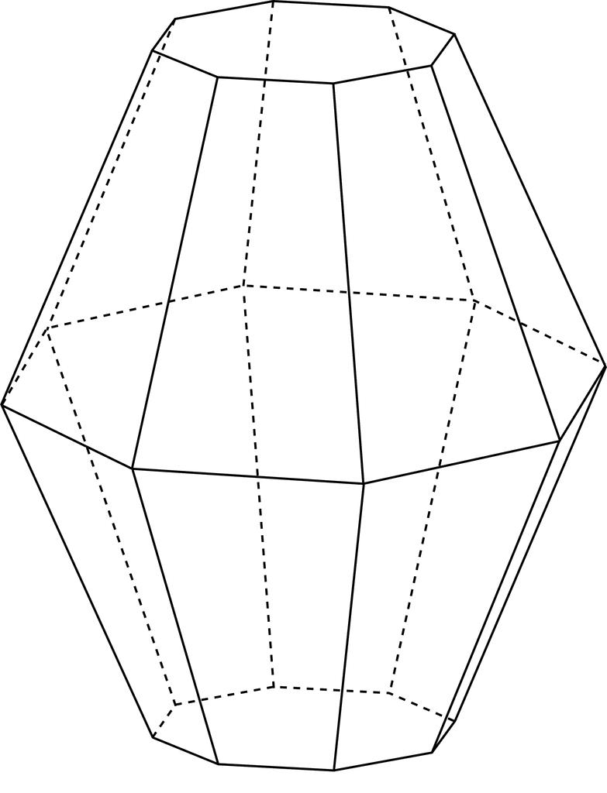
- Construct an octagon $ABCDEFGH$ as the lower base.
- Draw a parallel upper construction plane at the required perpendicular height.
- Construct a second octagon $A'B'C'D'E'F'G'H'$ on the upper plane.
- Determine the corresponding positions of the eight upper vertices.
- Check that each pair of corresponding base edges and connecting lateral edges defines a planar quadrilateral.
- Connect the corresponding vertices.
- Complete all eight lateral faces.
- Verify that the upper and lower bases are parallel.
- Finalize the drawing by removing auxiliary lines and marking visible and hidden edges.

Method 3: Constructing Through Parallel Cross-Sections
# Source: AI Source: Provided by: [Data Path: Persons Table -> ID Column: 1, Name_En Column: Motasem Essam] -> From: [ChatGPT] on [7/25/2026]
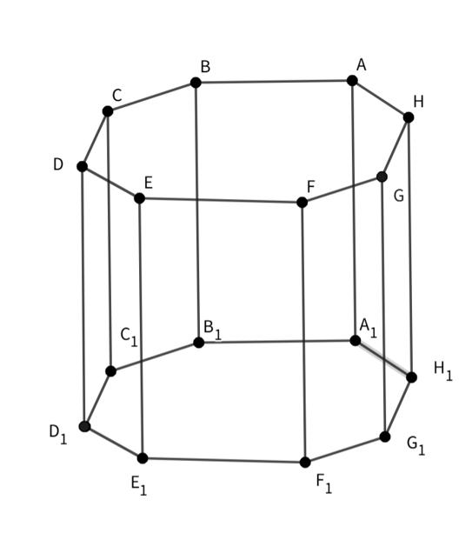
- Draw the lower octagonal base $ABCDEFGH$.
- Establish the perpendicular height of the solid.
- Mark the halfway level between the two bases.
- Construct a middle octagonal cross-section $A_{m}B_{m}C_{m}D_{m}E_{m}F_{m}G_{m}H_{m}$, parallel to the bases.
- Construct the upper octagonal base $A'B'C'D'E'F'G'H'$.
- Connect the corresponding vertices of the lower, middle, and upper octagons.
- Ensure that the resulting lateral faces are planar quadrilaterals.
- Complete the visible and hidden edges.
The middle cross-section is used to calculate the volume using the prismoidal formula.

Related Geometric Solids
# Source: AI Source: Provided by: [Data Path: Persons Table -> ID Column: 1, Name_En Column: Motasem Essam] -> From: [ChatGPT] on [7/25/2026]
- Octagonal Prism
- Octagonal Pyramidal Frustum
- Octagonal Prismatoid
- Heptagonal Prismoid
- Nonagonal Prismoid

Main Classification
# Source: AI Source: Provided by: [Data Path: Persons Table -> ID Column: 1, Name_En Column: Motasem Essam] -> From: [ChatGPT] on [7/25/2026]
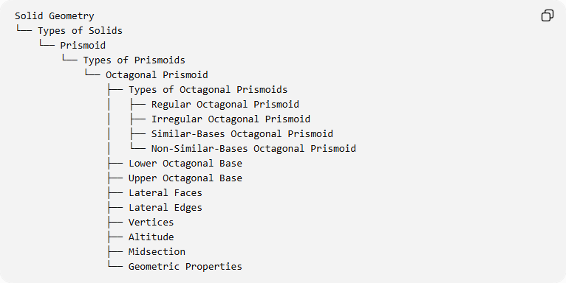
Solid Geometry
└── Types of Solids
└── Prismoid
└── Types of Prismoids
└── Octagonal Prismoid
├── Types of Octagonal Prismoids
│ ├── Regular Octagonal Prismoid
│ ├── Irregular Octagonal Prismoid
│ ├── Similar-Bases Octagonal Prismoid
│ └── Non-Similar-Bases Octagonal Prismoid
├── Lower Octagonal Base
├── Upper Octagonal Base
├── Lateral Faces
├── Lateral Edges
├── Vertices
├── Altitude
├── Midsection
└── Geometric Properties

Key Points
# Source: AI Source: Provided by: [Data Path: Persons Table -> ID Column: 1, Name_En Column: Motasem Essam] -> From: [ChatGPT] on [7/25/2026]
- An octagonal prismoid has two parallel octagonal bases.
- It contains 10 faces, 24 edges, and 16 vertices.
- Its eight lateral faces are quadrilaterals.
- Its volume can be calculated using the prismoidal formula.
- It belongs to the family of prismoids.

Conclusion
# Source: AI Source: Provided by: [Data Path: Persons Table -> ID Column: 1, Name_En Column: Motasem Essam] -> From: [ChatGPT] on [7/25/2026]
The Octagonal Prismoid is a polyhedron formed by two parallel octagonal bases connected by eight quadrilateral lateral faces. Its structure follows the general properties of prismoids, with a total of 10 faces, 24 edges, and 16 vertices.

